**Assignment 1**

**ProperCase:**

Convert document into propercase.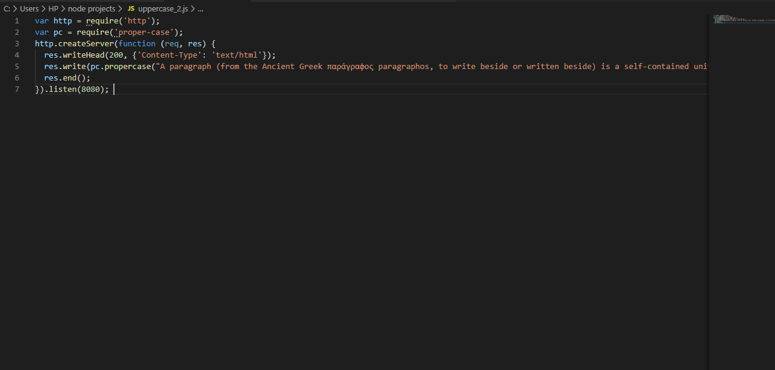

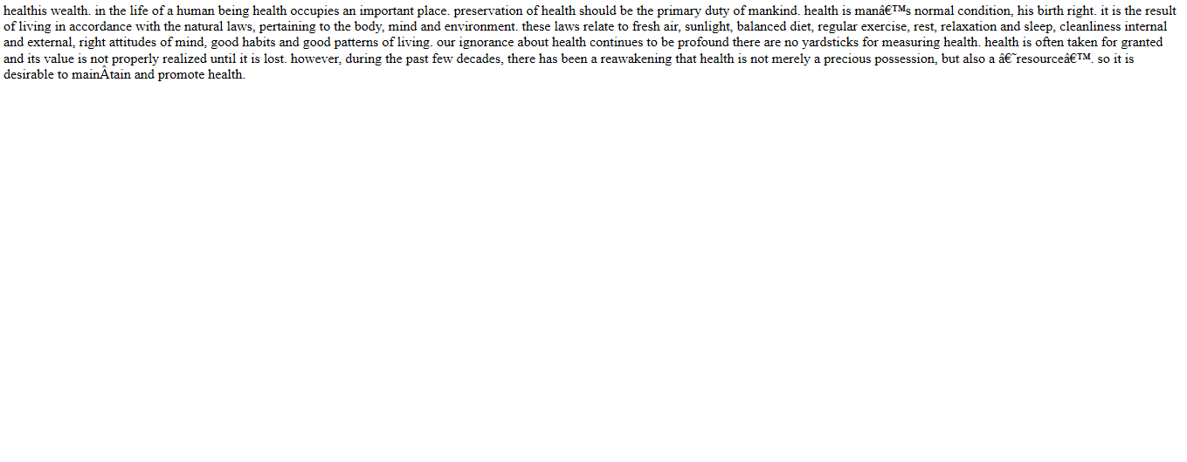

**Sentiment Analysis**

Gives result if uploaded document have positive or negative text. Give polarity of document.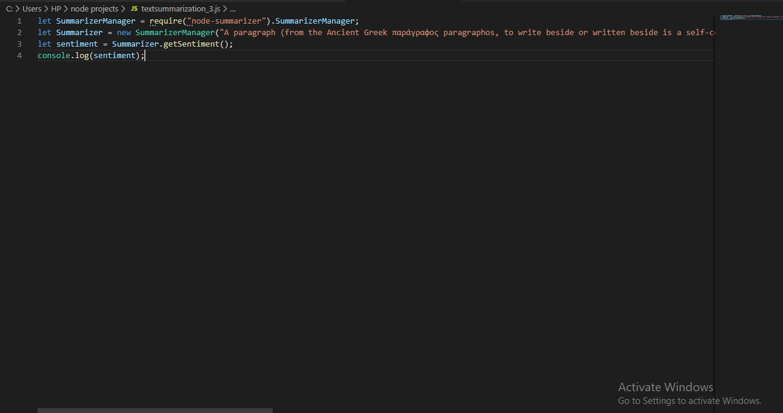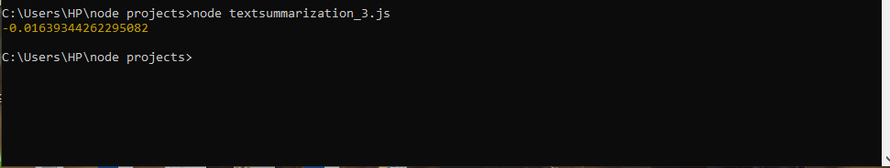

**Text Summarization**

Results provides summary of uploaded document paragraph in one like.